solar powered MICROCONTROLLER BASED AUTO IRRIGATION SYSTEM and remote monitoring

This project report is submitted in partial fulfillment of the requirements for the Degree of Bachelor of Science in Electrical and Electronic Engineering

Submitted by

Md. Farhad Ahmmed

ID: 143-33-2280

Md. Mhabub Alam

ID: 143-33-2256

Supervised by

Dr. Md. Rezwanul Ahsan

Assistant Professor

Department of Electrical & Electronic Engineering

Faculty of Engineering



Department of Electrical and Electronic Engineering

Faculty of Engineering

DAFFODIL INTERNATIONAL UNIVERSITY

December 2017

CERTIFICATION

This is to certify that this project entitled “SOLAR POWERED MICROCONTROLLER BASED AUTO IRRIGATION SYSTEM AND REMOTE MONITORING’’ is done by the following students under my direct supervision. This project work has been carried out by them in the laboratories of the Department of Electrical and Electronic Engineering under the Faculty of Engineering, Daffodil International University in partial fulfillment of the requirements for the degree of Bachelor of Science in Electrical and Electronic Engineering. The presentation of the work was held on….

**Signature of the candidates**

### _____________________

**Md. Farhad Ahmmed**

Reg ID: 143-33-2280

________________________

**Md. Mhabub Alam**

Reg ID: 143-33-2256

**Signature of the supervisor**

Dr. Md. Rezwanul Ahsan

The project entitled “SOLAR POWERED MICROCONTROLLER BASED AUTO IRRIGATION SYSTEM AND REMOTE MONITORING” submitted by **Md. Farhad Ahmmed,** Reg ID: **143-33-2280**, **Md. Mhabub Alam,** Reg ID: **143-33-2256**, Session: Fall 2014 has been accepted as satisfactory in partial fulfillment of the requirements for the degree of Bachelor of Science in Electrical and Electronic Engineering December 2017.

BOARD OF EXAMINERS

____________________________

Dr. Engr.  ---                                       Chairman

Professor

Department of EEE, DIU

____________________________

Dr. Engr. ---                                     Internal Member

Professor

Department of EEE, DIU

____________________________

Dr. Engr. ---                                        Internal Member

Professor

Department of EEE, DIU

### TO

### OUR BELOVED PARENTS

### &

### HONOURABLE SUPERVISER

### Dr. Md. Rezwanul Ahsan

CONTENTS

|  |  |
| --- | --- |
| List of Figures | x |
| List of Tables | xiii |
| List of Abbreviations | xiv |
| Acknowledgement | xv |
| Abstract | xvi |

|  |  |  |
| --- | --- | --- |
| **CHAPTER 1** | **INTRODUCTION** | **1-7** |
| 1.1 | Introduction |  |
| 1.2 | Problem Statement |  |
| 1.3 | Aim of the Project |  |
| 1.4 | Scope of the Project |  |
| 1.5 | Project Outlines |  |
|  |  |  |
| **CHAPTER 2** | **SYSTEM REVIEW** |  |
| 2.1 | Introduction |  |
| 2.2 | History of Soil Moisture Sensor |  |
| 2.3 | History of Relay |  |
| 2.4 | History of Automatic Irrigation System |  |
| 2.5 | Microcontroller |  |
| 2.6 | Why Microcontroller is used |  |
| 2.7 | Soil Moisture Sensor |  |
|  |  |  |
| **CHAPTER 3** | **THEORETICAL MODEL** |  |
| 3.1 | Introduction |  |
| 3.2 | Flow Chart |  |
|  |  |  |
|  |  |  |
|  |  |  |
|  |  |  |
|  |  |  |
| **CHAPTER 4** | **HARDWARE DEVELOPMENT** |  |
| 4.1 | Introduction |  |
| 4.2 | Components Name and Quantity |  |
|  |  |  |
|  |  |  |
|  |  |  |
|  |  |  |
|  |  |  |
|  |  |  |
|  |  |  |
|  |  |  |
|  |  |  |
|  |  |  |
|  |  |  |
|  |  |  |
|  |  |  |
|  |  |  |
|  |  |  |
|  |  |  |
|  |  |  |
| **CHAPTER 5** | **RESULTS AND DISCUSSIONS** | **70-79** |
| 5.1 | Introduction | 70 |
| 5.2 | Results | 70 |
| 5.3 | Project Physical View | 77 |
| 5.4 |  | 78 |
|  |  |  |
|  |  |  |
|  |  |  |
|  |  |  |
|  |  |  |
| **CHAPTER 6** | **CONCLUSIONSION** | **80-81** |
| 6.1 | Conclusion | 80 |
| 6.2 | Limitations of the Work | 80 |
| 6.3 | Future Scope | 80 |
|  |  |  |
| **REFERENCES** | | **82** |

LIST OF FIGURES

|  |  |  |
| --- | --- | --- |
| Fig.1.1 | Microcontroller |  |
| Fig.1.2 | Relay Pin Configurations |  |
|  |  |  |
|  |  |  |
|  |  |  |
|  |  |  |
|  |  |  |
|  |  |  |
|  |  |  |
|  |  |  |
|  |  |  |
|  |  |  |
|  |  |  |
|  |  |  |
|  |  |  |
|  |  |  |
|  |  |  |
|  |  |  |
|  |  |  |
|  |  |  |
|  |  |  |
|  |  |  |
|  |  |  |
|  |  |  |
|  |  |  |
|  |  |  |
|  |  |  |
|  |  |  |
|  |  |  |
|  |  |  |
|  |  |  |
|  |  |  |
|  |  |  |
|  |  |  |
|  |  |  |

LIST OF TABLES

|  |  |  |
| --- | --- | --- |
| Table.3.1 |  |  |
| Table.3.2 |  |  |
|  |  |  |
|  |  |  |
|  |  |  |
|  |  |  |
|  |  |  |
|  |  |  |
|  |  |  |
|  |  |  |
|  |  |  |
|  |  |  |
|  |  |  |
|  |  |  |
|  |  |  |
|  |  |  |
|  |  |  |
|  |  |  |

**LIST OF ABBREVIATIONS**

GSM Global System for Mobile

PCB Printed Circuit Board

LCD Liquid Crystal Display

FDR Frequency Domain Reflectometry

TDT Time Domain Transmission

ACKNOWLEDGEMENT

Firstly give thanks to almighty Allah from the core of our hearts. We would like to express our sincere gratitude to our honorable supervisor **Mr.** Dr. Md. Rezwanul Ahsan Assistant Professor of **Department of EEE** for being dedicated in supporting, motivating and guiding us through this project. This project can’t be done without his useful advice and helps. Also thank you very much for giving us opportunity to choose this project.

We also want to convey our thankfulness to **Dr. M Shamsul Alam, Dean, and Department of EEE** for his help, support and constant encouragement.

We express our humble gratitude to all teachers of department of Electrical and Electronic Engineering for their support in numerous ways throughout this project work. We are also grateful to the authors whose valuable research papers and books we have considered as reference in this project paper.

Apart from that, we would like to thank our entire friends for sharing knowledge; information and helping us in making this project a success. Also thanks for lending us some tools and equipment.

Finally we would like to thank our parents who have given us tremendous inspirations and supports. Without mental and financial supports, we would not able to complete our project.

ABSTRACT

The project is designed to develop an automatic irrigation system which switches the pump motor ON/OFF on sensing the moisture content of the soil. In the field of agriculture, use of proper method of irrigation is important. The advantage of using this method is to reduce human intervention and still ensure proper irrigation. The project uses a microcontroller with AT Mega 328 Series microcontroller which is programmed to receive the input signal of varying moisture condition of the soil through the sensing arrangement. Once the controller receives this signal, it generates an output that drives are lay for operating the water pump. An automation of irrigation systems has several positive effects. Once installed, the water distribution on fields or small-scale gardens is easier and does not have to be permanently controlled by an operator. There are several solutions to design automated irrigation systems.

Chapter 1

INTRODUCTION

1.1 Introduction

By using the concept microcontroller based automatic irrigation system a gardener or farmer can save water up to 50% and power. This concept depends on two irrigation methods those are conventional irrigation methods like overhead plant sprinklers, flood type feeding system i.e. wet the lower leaves and stem of the plants. The area between the crop rows become dry as the large amounts of water is consumed by the flood type methods, in which case the farmer depends only on the incidental rainfalls. The crops are been infected by the leaf mold fungi as the soil surface often stays wet and is saturated after irrigation is completed. Overcoming these drawbacks new techniques are been adopted in the irrigation techniques, through which small amounts of water applies to the parts of root zone of the plant. The plant soil moisture stress is prevented by providing required amount of water resources frequently or often daily by which the moisture condition of the soil will retain well. The diagram below shows the entire concept of the modern irrigation system. The traditional techniques like sprinkler or surface irrigation requires nearly half of water sources. Even more precise amounts of water can be supplied for plants. As far as the foliage is dry the plant damage due to disease and insects will be reduced, which further reduces the operating cost. The dry rows between plants will leads to continuous federations during the irrigation process. Fertilizers can be applied through this type of system, and the cost required for will also reduce. The erosion of soil and wind is much reduced by the recent techniques when compared with overhead sprinkler system. The soil characteristics will define the form of the dripping nature in the root zone of a plant which receives moisture. AS the method of dripping will reduce huge water losses it became a popular method by reducing the labor cost and increasing the yields. When the components are activated, all the components will read and gives the output signal to the controller, and the information will be displayed to the farmer. The sensor readings are analog in the nature so the ADC pin in the controller will convert the analog signals into digital format. Then the controller will access information and when the motors are turned on/off it will be displayed on the LCD panel.

1.2 Problem Statement

Irrigation of plants is usually a very nice time- consuming activity, so to be done in a reasonable amount of time, it requires a large amount of human resources. Traditionally all the steps were executed by humans. Nowadays some systems use technology to reduce the number or workers or the time required to water the plants. With such a system, the control is very limited, and many resources are still wasted. Water is one of these resources that are used excessively. Many irrigation is one method used to water plant. This method represents massive losses since the amount of water given is in excess of the plant’s needs. The excess water is evacuated by the holes of the pots in greenhouses, or it percolates through the soil in the fields. The contemporary perception of water is that of a free renewable resource that can be used in abundance. It is therefore reasonable to assume that it will soon become a very expensive resource everywhere. In addition to the excess cost of water labor is becoming more and more expensive. As a result, if no effort is invested in optimizing these resources, there will be more money involved in the same process. Technology is probably a solution to reduce costs and prevent loss of resource; this project can be a strong way to tackle such a situation.

1.3 Aim of project

* The main objective of this project is to design a low cost device in order to control the water pump automatically. .
* To save farmers effort, water and time. Irrigation management is a complex decision.
* The ability to conserve the natural resources as w ell as giving a splendid boost to the production of the crops is one of the main aims of incorporating such technology into the agricultural domain of the country.

1.4 Scopes of Project

A critical consideration is the installation costs, since costs generally determine the feasibility and viability of a project. The installation must be simple enough for a domestic user. The water saving was also an important aspect, since there is a demand to minimize water loss and to minimize the efficiency of water used. Finally, the possibility for implementing the system at a larger scale should be investigated.

**2**

 1.5 Outline of the Project Report

This project report is organized as follows:

Chapter -1 Introduction of the project

Chapter-2 System reviews

Chapter-3 Theoretical model

Chapter-4 Hardware development

Chapter-5 Result and discussion

Chapter-6 Conclusion

CHAPTER 2

SYSTEM REVIEWS

2.1 Introduction

This chapter will contain information about automatic irrigation. Here we will also discuss microcontroller and choosing reason. Also, contains moister sensor and its history.

2.2 History of Automatic Irrigation system

Irrigation system uses valves to turn irrigation ON and OFF. These valves may be easily automated by using controllers and solenoids. Automating farm or nursery irrigation allows farmers to apply the right amount of water at the right time, regardless of the availability of labor to turn valves on and off. In addition, farmers using automation equipment are able to reduce runoff from over watering saturated soils, avoid irrigating at the wrong time of day, which will improve crop performance by ensuring adequate water and nutrients when needed. Automatic Drip Irrigation is a valuable tool for accurate soil moisture control in highly specialized greenhouse vegetable production and it is a simple, precise method for irrigation. It also helps in time saving, removal of human error in adjusting available soil moisture levels and to maximize their net profits. Irrigation is the artificial application of water to the soil usually for assisting in growing crops. In crop production it is mainly used in dry areas and in periods of rainfall shortfalls, but also to protect plants against frost.

Types of Irrigation Surface irrigation

* Localized irrigate ion
* Drip Irrigation
* Sprinkler irrigation

Conventional irrigation methods like overhead sprinklers, flood type feeding systems usually wet the lower leaves and stem of the plants. The entire soil surface is saturated and often stays   wet long after irrigation is completed. Such condition promotes infections by leaf mold fungi. On the contrary the drip or trickle irrigation is a type of modern irrigation technique that slowly applies small amounts of water to part of plant root zone. Water is supplied frequently, often daily to maintain favorable soil moisture condition and prevent moisture stress in the plant with proper use of water resources. Drip irrigation saves water because only the plant’s root zone receives moisture. Little water is lost to deep percolation if the proper amount is applied. Drip irrigation is popular because it can increase yields and decrease both water requirements and labor. Drip irrigation requires about half of the water needed by sprinkler or surface irrigation. Lower operating pressures and flow rates result in reduced energy costs. A higher degree of water control is attainable. Plants can be supplied with more precise amounts of water. Disease and insect damage is reduced because plant foliage stays dry. Operating cost is usually reduced. Federations may continue during the irrigation process because rows between plants remain dry.

2.3 Microcontroller

A microcontroller (or MCU for microcontroller unit) is a small computer on a single integrated circuit. In modern terminology, it is similar to, but less sophisticated than, a system on a chip may include a microcontroller as one of its components. A microcontroller contains one or more CPUs (processor cores) along with memory and programmable input/output peripherals. Program memory in the form of Ferroelectric RAM, NOR flash or OTP ROM is also often included on chip, as well as a small amount of RAM.

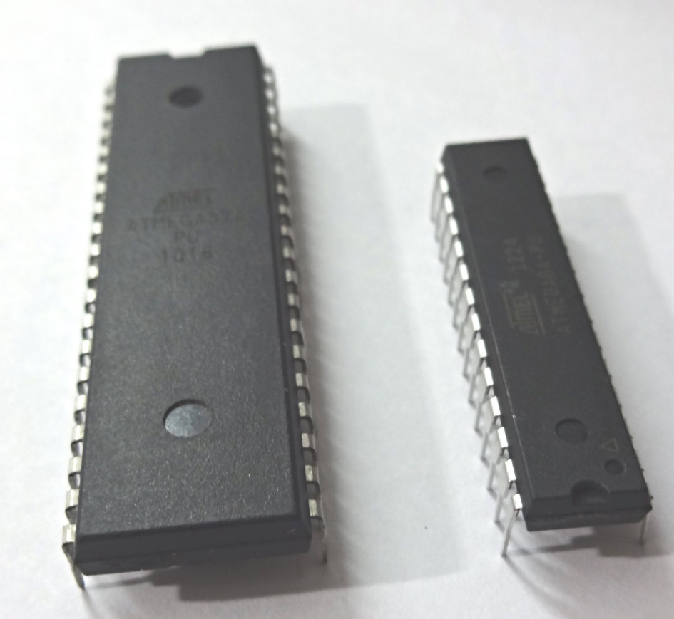

Fig. 2.1: Microcontroller

Microcontrollers are designed for embedded applications, in contrast to the microprocessors used in personal computers or other general purpose applications consisting of various discrete chips.

2.4 Why using Microcontroller

Microcontrollers are used in automatically controlled products and devices, such as automobile engine control systems, implantable medical devices, remote controls, office machines, appliances, power tools, toys and other embedded systems. By reducing the size and cost compared to a design that uses a separate microprocessor, memory, and input/output devices, microcontrollers make it economical digitally control even more devices and processes. Mixed signal microcontrollers are common, integrating analog components needed to control non-digital electronic systems.

2.5 Soil Moisture Sensor

Two types of soil moisture sensors are available in the market—contact and non-contact sensors. A contact soil sensor is used in this project because it has to check soil moisture to measure the electrical conductivity. The moisture sensor provides an analogue output, which can easily be interfaced with microcontroller. In this project, two sensors can be connected to analogue pins, A0 and A1, of the microcontroller. Each sensor has four pins (VCC, Gnd, Ao and Do) available for interfacing with the microcontroller board. Here, digital output pin (Do) is not used. The water pump and servo motor are controlled by microcontroller connected to digital pins 3 and 9, respectively. That is, the servo motor signal control pin is connected to pin 9 of the microcontroller.

2.6 History of Soil moister sensor

Technologies commonly used to indirectly measure volumetric water content (soil moisture) include)

* Frequency Domain Reflectometry (FDR): The dielectric constant of a certain volume element around the sensor is obtained by measuring the operating frequency of an oscillating circuit.
* Time Domain Transmission (TDT) and Time Domain Reflectometry (TDR): The dielectric constant of a certain volume element around the sensor is obtained by measuring the speed of propagation along a buried transmission line.
* Neutron moisture gauges: The moderator properties of water for neutrons are utilized to estimate soil moisture content between a source and detector probe.
* Soil resistivity: Measuring how strongly the soil resists the flow of electricity between two electrodes can be used to determine the soil moisture content.
* Galvanic cell: The amount of water present can be determined based on the voltage the soil produces because water acts as an electrolyte and produces electricity. The technology behind this concept is the galvanic cell.

2.7 History of relay

American scientist Joseph Henry is often claimed to have invented a relay in 1835 in order to improve his version of the electrical telegraph, developed earlier in 1831. However, there is little in the way of official documentation to suggest he had made the discovery prior to 1837. It is claimed that English inventor Edward Davy *"certainly invented the electric relay"* in his electric telegraph 1835.

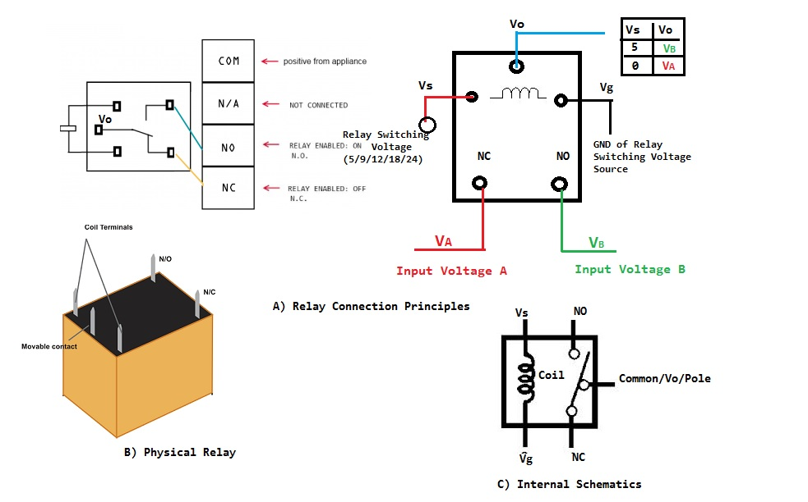

Fig. 2.2: Relay pin configuration

A simple device, which is now called a relay, was included in the original 1840 telegraph patent of Samuel Morse. The mechanism described acted as a digital amplifier, repeating the telegraph signal, and thus allowing signals to be propagated as far as desired. This overcame the problem of limited range of earlier telegraphy schemes. The word *relay* appears in the context of electromagnetic operations from 1860.

CHAPTER 3

Theoretical Model

3.1 Introduction

Project, Atmega328 microcontroller will be used to program an application The Moister sensor will detect the moister level send analog data signal to microcontroller. The microcontroller will use the data to process, analyze and calculate the specific information about the moister, and then it will be display on a 16x2 screen (LCD – 16x2).

3.2 Flow chart

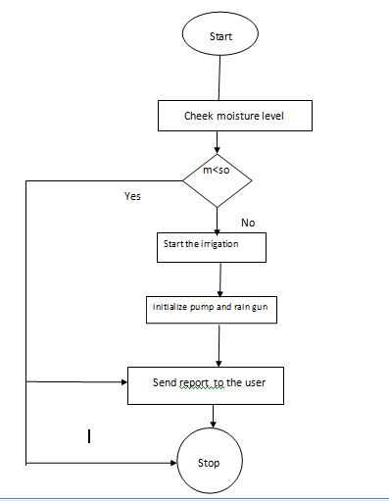

Fig. 3.1: Flow chart of project

3.3 Block Diagram of microcontroller Based Automatic Irrigation System

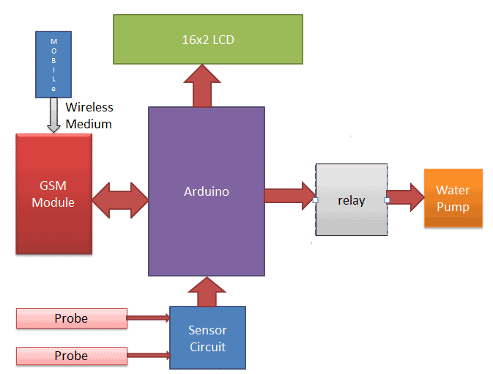

Fig. 3.2: Block diagram of automatic irrigation system

Moisture sensor detects the moister from the plan soil. It sends analog to microcontroller detect the signal, Process and calculate the data. Microcontroller sends data on LCD. It shows us the data and we can also able to see the data. Every unit is connected to power supply which is a prerequisite for operation.

3.4 Working procedure

At first in our project, microcontroller is used to control the whole process, LCD used to display moisture level and water pump status. We also used buzzer for a warning system when our system is ready to work. .We place our moister sensor into the soil, it detects moisture from soil and sends analog information to microcontroller. Now microcontroller receive the analog signal and processing and check the condition and decide pump ON or Off, At the same time calculate the signal then it sends the calculated data to LCD.

3.5 Schematic Diagram

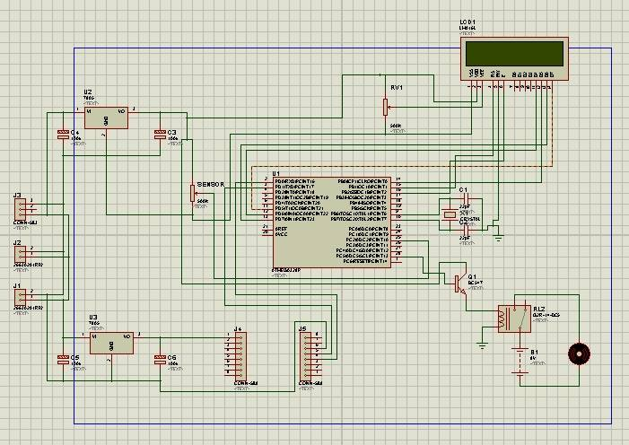

Fig. 3.3: Schematic Diagram of auto irrigation system

3.6 PCB design

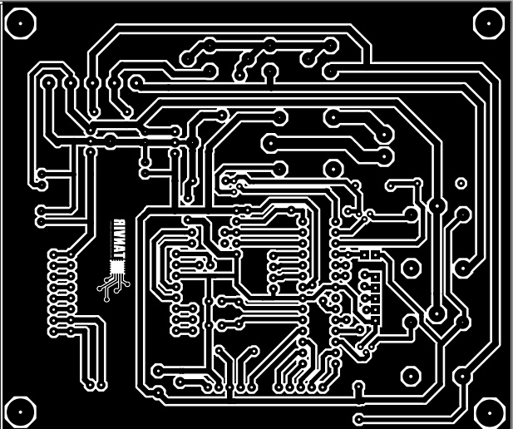

Fig. 3.4: PCB Deign

CHAPTER 4

HARDWARE DEVELOPMENT

4.1 Introduction

In this chapter, we will discuss about the hardware component that have used in our project. This part will explain the path needed to undertake in order to achieve the goal of the project.

4.2 Components Name and Quantity

Table 4.1: Components Name and Quantity

|  |  |  |
| --- | --- | --- |
| **SL** | **Components** | **Quantity** |
| 1 | Microcontroller | 1 pcs |
| 2 | Moisture sensor | 2 pcs |
| 3 | 16*2 LCD | 1 pcs |
| 4 | 9 volt Dc water pump | 1 pcs |
| 5 | ON/OFF switch | 3 pcs |
| 6 | 5 v Relay | 1 pcs |
| 7 | Power source(9v, 2A and 5v,1A) | 1 pcs |
| 8 | Connecting Wire | As Require |
| 9 | Water Bottle | 2 pcs |
| 10 | Plastic Box | 1 pcs |
| 11 | DC Power socket | 2 pcs |
| 12 | Plastic Pipe | 6 fit |
| 13 | PVC Board | 1 fit |
| 14 | BC547 Transistor | 2 pcs |
| 15 | Connector | 2 pcs |
| 16 | IN4007 Diode | 2 pcs |
| 17 | Heat Sink | 2 pcs |
| 18 | Variable Resistor 5k | 2 pcs |
| 19 | Capacitor 22 PF | 2 pcs |
| 20 | 1k/10k Resistor | 2 pcs |
| 21 | Capacitor 100UF | 3 pcs |

4.3 Soil Moisturizer sensor

Soil moisture sensors measure the volumetric water content in soil. Since the direct gravimetric measurement of free soil moisture requires removing, drying, and weighting of a sample, soil moisture sensors measure the volumetric water content indirectly by using some other property of the soil, such as electrical resistance, dielectric constant, or interaction with neutrons, as a proxy for the moisture content. The relation between the measured property and soil moisture must be calibrated and may vary depending on environmental factors such as soil type, temperature, or electric conductivity. Reflected microwave radiation is affected by the soil moisture and is used for remote sensing in hydrology and agriculture. Portable probe instruments can be used by farmers or gardeners.

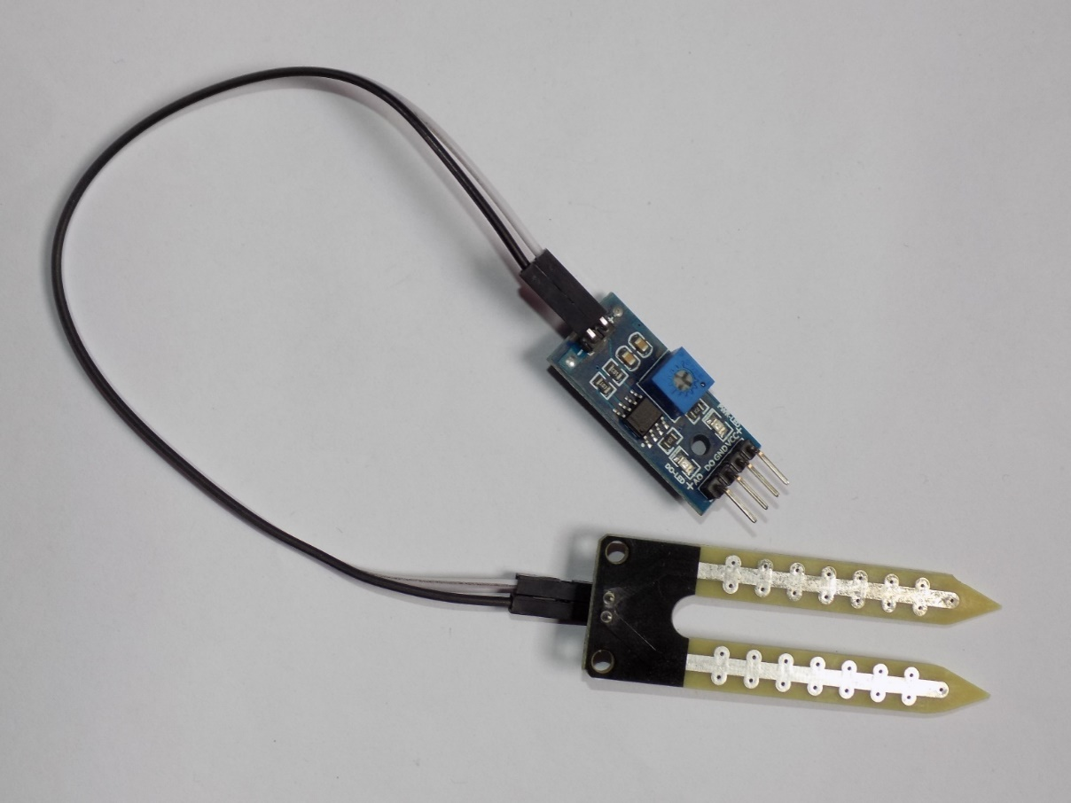

Fig4.1: Moisture sensor Front View Soil

4.3.1 Hardware Features of Soil moisture sensor

Table 4.2: Hardware Features

|  |  |
| --- | --- |
| **Sensitivity** | Adjustable Sensitivity |
| **Module Mode** | Output mode, a simple digital output, analog output Module mode more accurate. Simple digital output, analog output more accurate. |
| **Operating Voltage** | 3.3v-5v |
| With edge connector | |
| D0 small board digital output interfaces ( 0 and 1 ) | |
| Ao small board analog output interface | |

4.3.2 Technology

Technologies commonly used to indirectly measure volumetric water content (soil moisture include)

* Frequency Domain Reflectometry (FDR): The dielectric constant of a certain volume element around the sensor is obtained by measuring the operating frequency of an oscillating circuit.
* Time Domain Transmission (TDT) and Time Domain Reflectometry (TDR): The dielectric constant of a certain volume element around the sensor is obtained by measuring the speed of propagation along a buried transmission line.
* Neutron moisture gauges: The moderator properties of water for neutrons are utilized to estimate soil moisture content between a source and detector probe.
* Soil resistivity: Measuring how strongly the soil resists the flow of electricity between two electrodes can be used to determine the soil moisture content.
* Galvanic cell: The amount of water present can be determined based on the voltage the soil produces because water acts as an electrolyte and produces electricity. The technology behind this concept is the galvanic cell.

4.3.3 Applications

**Agriculture:** Measuring soil moisture is important for agricultural applications to help farmers manage their irrigation systems more efficiently. Knowing the exact soil moisture conditions on their fields, not only are farmers able to generally use less water to grow a crop, they are also able to increase yields and the quality of the crop by improved management of soil moisture during critical plant growth stages.

**Landscape irrigation:** In urban and suburban areas, landscapes and residential lawns are using soil moisture sensors to interface with an irrigation controller. Connecting a soil moisture sensor to a simple irrigation clock will convert it into a "smart" irrigation controller that prevents irrigation cycles when the soil is already wet, e.g. following a recent rainfall event. Golf courses are using soil moisture sensors to increase the efficiency of their irrigation systems to prevent over-watering and leaching of fertilizers and other chemicals into the ground.

**Research:** Soil moisture sensors are used in numerous research applications, e.g. in agricultural science and horticulture including irrigation planning, climate research, or environmental science including solute transport studies and as auxiliary sensors for soil respiration measurements.

**Simple for gardeners:** Relatively cheap and simple devices that do not require a power source are available for checking whether plants have sufficient moisture to thrive. After inserting a probe into the soil for approximately 60 s sends, a meter indicates if the soil is too dry, moist or wet for plants.

4.4 Relay Module

This is a LOW Level 5V 2-channel relay interface board, and each channel needs a 15-20mA driver current. It can be used to control various appliances and equipment with large current. It is equipped with high-current relays that work under AC250V 10A or DC30V 10A. It has a standard interface that can be controlled directly by microcontroller.

* COM- Common pin.
* NC- Normally Closed, in which case NC is connected with COM when INT1 is set low and disconnected when INT1 is high.
* NO- Normally Open, in which case NO is disconnected with COM1 when INT1 is set low and connected when INT1 is high.

Terminal 2 is similar to terminal 1, except that the control port is INT2

* INT 1- Relay 1 control port
* INT 2- Relay 2 control port

### 

Fig. 4.2: (a) Relay Module Top View and (b) Relay Module circuit Diagram

4.5 LCD Display

LCD (Liquid Crystal Display) screen is an electronic display module and find a wide range of applications. A 16x2 LCD display is very basic module and is very commonly used in various devices and circuits. These modules are preferred over seven segments and other multi segment LCDs. The reasons being: LCDs are economical; easily programmable; have no limitation of displaying special & even custom characters (unlike in seven segments), animations and so on, A 16x2 LCD means it can display 16 characters per line and there are 2 such lines. In this LCD, each character is displayed in 5x7 pixel matrix. This LCD has two registers, namely, Command and Data. The command register stores the command instructions given to the LCD. A command is an instruction given to LCD to do a predefined task like initializing it, clearing its screen, setting the cursor position, controlling display etc. The data register stores the data to be displayed on the LCD. The data is the ASCII value of the character to be displayed on the LCD. Click to learn more about internal structure of a LCD.

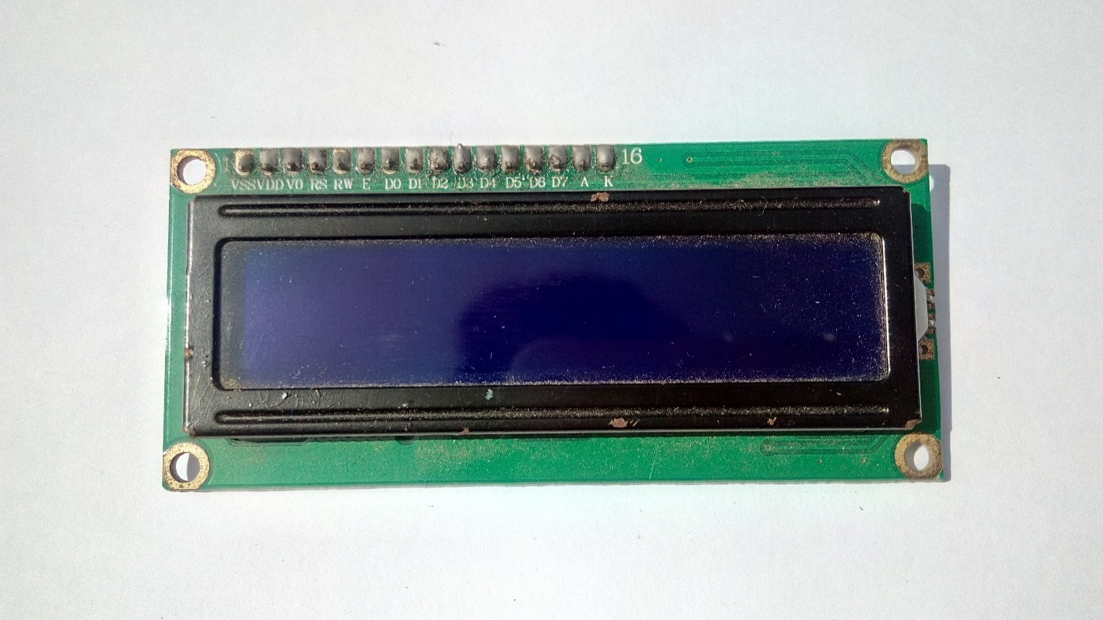

Fig. 4.3: 16*2 LCD display

Pin description as follows

→ Pin 7 to pin 14 all 8 pins are responsible for the transfer of data.

→ Pin 4-This is Rs i.e., register select pin.

→ Pin 5-This is R/W i.e., Read/Write pin.

→ Pin 6-This is E i.e., enable pin.

→ Pin 2-This is VDD i.e., power supply pin

→ Pin1-This is VSS i.e., ground pin.

→ Pin3-This is short pin.

4.6 Capacitor

A device used to store an electric charge, consisting of one or more pairs of conductors separated by an insulator. A capacitor is a passive two-terminal electrical component that stores electrical energy in an electric field. The effect of a capacitor is known as capacitance. Capacitance is defined as the ratio of the electric charge on each conductor to the potential difference between them. The unit of capacitance in the [International System of Un).its](https://en.wikipedia.org/wiki/International_System_of_Units) (SI) is the [farad](https://en.wikipedia.org/wiki/Farad) (F).

4.6.1 Polarized capacitor

All electrolytic capacitors (e-caps) are polarized capacitors whose anode (+) is made of a metal that forms an insulating oxide layer through randomization. This oxide layer acts as the dielectric of the electrolytic capacitor.

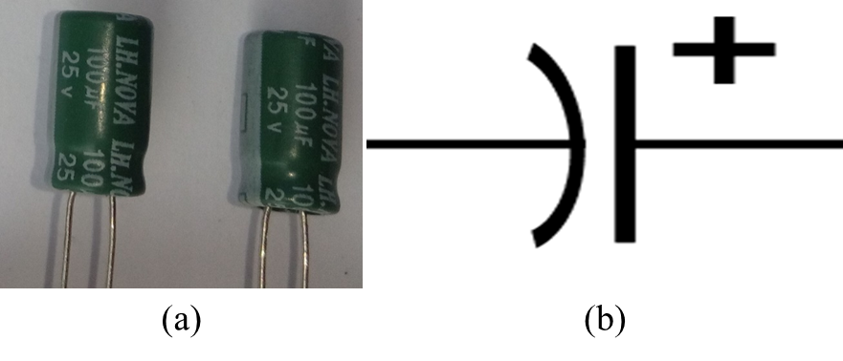

Fig. 4.5: (a) Polarized capacitor and (b) Symbol of Polarized capacitor

4.6.2 Non-polarized

A non-polarized (non-polar) capacitor is a type of capacitor that has no implicit polarity -- it can be connected either way in a circuit. Ceramic, mica and some electrolyte capacitors are non-polarized. You'll also sometimes hear people call them "bipolar" capacitors.

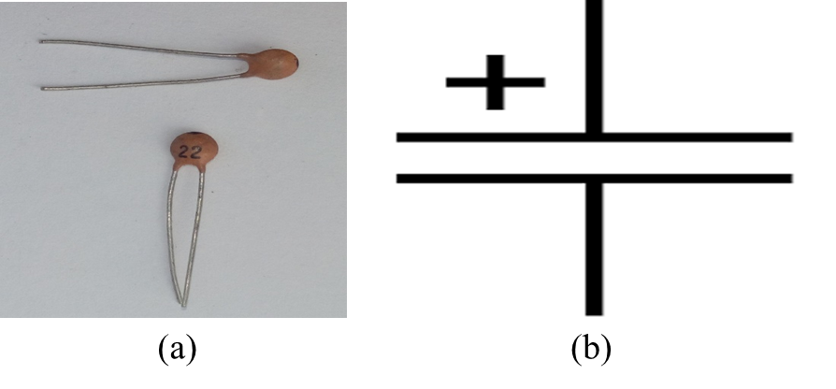

Fig. 4.6: (a) Non-polarized capacitor and (b) Symbol of Non-polarized capacitor

4.7 Crystal

A crystal or crystalline solid is a solid material whose constituents (such as atoms, molecules, or ions) are arranged in a highly ordered microscopic structure, forming a crystal lattice that extends in all directions. In addition, macroscopic single crystals are usually identifiable by their geometrical shape, consisting of flat faces with specific, characteristic orientations. The scientific study of crystals and crystal formation is known as crystallography. The process of crystal formation via mechanisms of crystal growth is called crystallization or solidification

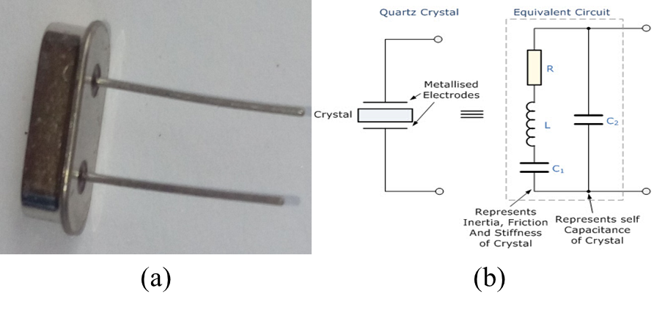

Fig. 4.7: (a) Crystal and (b) Crystal circuit

4.8 Resistor

A resistor is a passive two electrical that implements electrical resistance as a circuit element. The current through a resistor is in direct proportion to the voltage across the resistor's terminals. Thus, the ratio of the voltage applied across a resistor's terminals to the intensity of current through the circuit is called resistance. This relation is represented by Ohm's law:

*I = V $/R$*

Where *I* is the current through the conductor in units of amperes,

*V* is the potential difference measured across the conductor in units of volts,

And *R* is the resistance of the conductor in units.

4.8.1 Fixed Resistor

Fixed resistors are the most frequently used resistors in the electronic circuits. These resistors have the fixed resistance value. Hence, it is not possible to vary the resistance of the fixed resistor

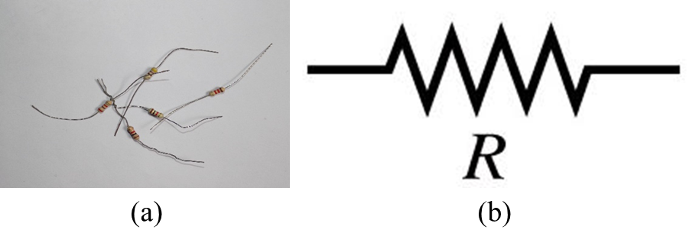

Fig. 4.9: (a) Fixed resistor and (b) Symbol of Fixed resistor

4.8.2 Variable Resistor

A rheostat is a variable resistor which is used to control current. They are able to vary the resistance in a circuit without interruption. It uses only two connections, even when 3 terminals (as in a potentiometer) are present.

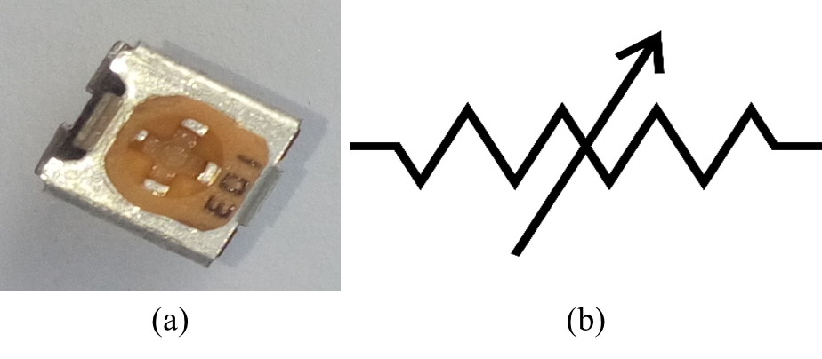

Fig. 4.11: (a) Variable resistor and (b) Symbol of Variable resistor

4.12 DC Power Supply

In this project, we used 9 volts dc adapter for external power source. This is a high-quality AC to DC 9V, 2A power supply. These power supplies mean the output is regulated to 9V and the capable output current is much higher (2000mA).And we also use 5v, 1A adapter for motor power supply.

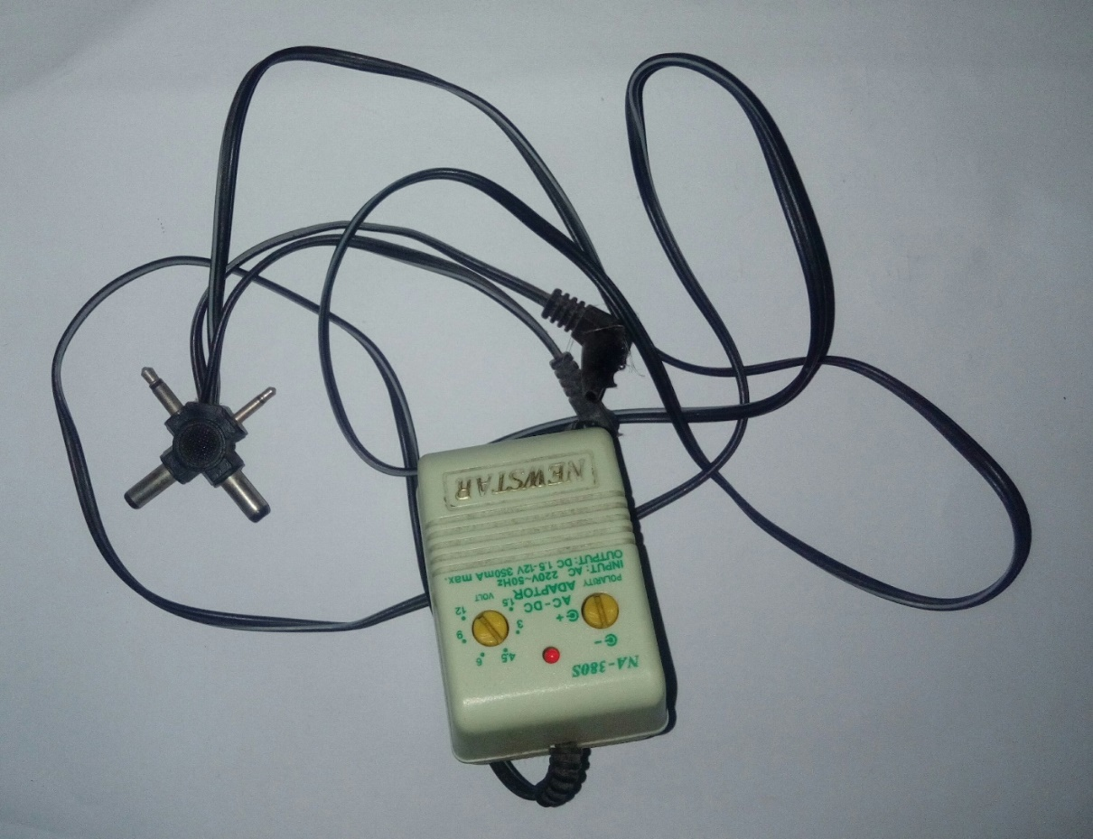

Fig. 4.13: 5V, 300mA DC power adapter

4.14 Water pump

The water pump is used to artificially supply water for a particular task. It can be electronically controlled by interfacing it to a microcontroller. It can be triggered ON/OFF by sending signals as required. The process of artificially supplying water is known as pumping. There are many varieties of water pumps used. This project employs the use of a small DC 6v water pump which is connected to a relay module.

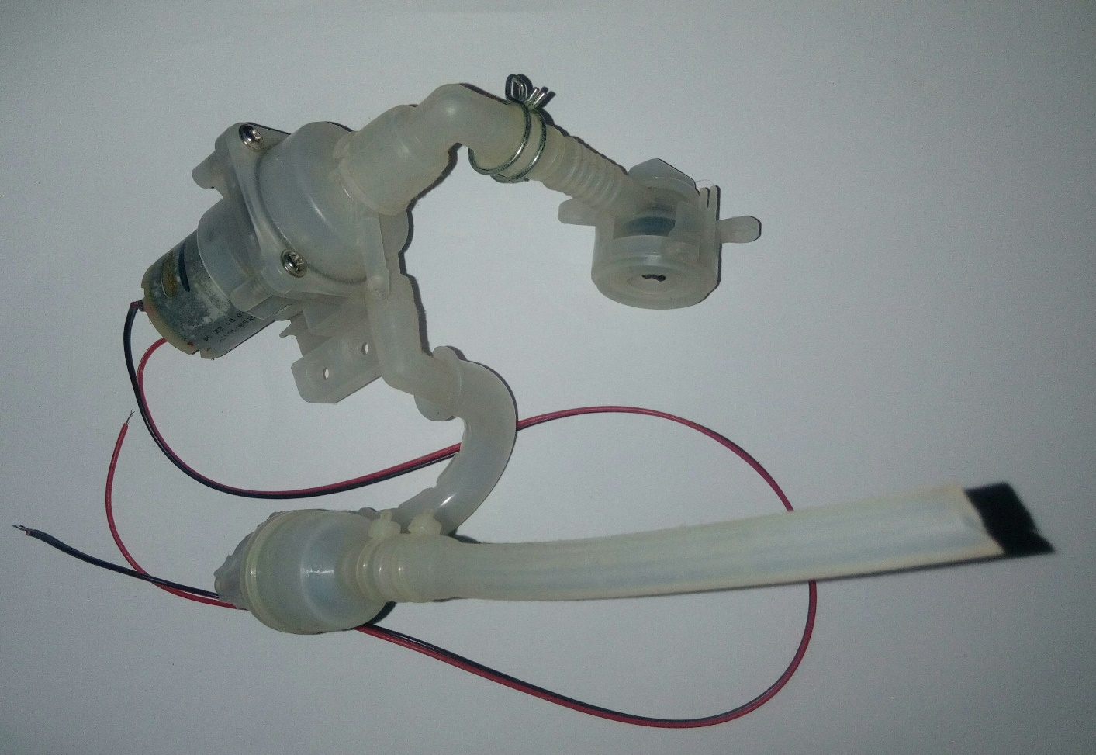

Fig. 4.14: Water pump

4.11 ON/OFF Switch

Specifications:

Voltage: 12V

Switch Color: White

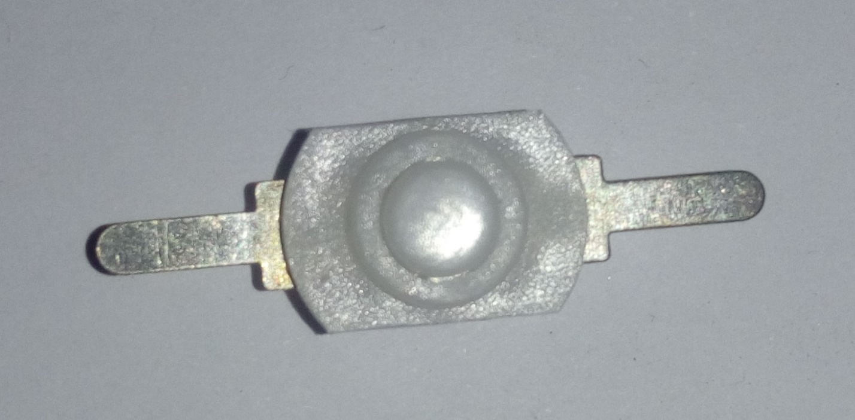

Fig. 4.15: ON/OFF switch

4.12 DC power Socket

This DC power connector has a 1.4mm centre pin. The cable mount DC connector is easy to wire and is suitable for a wide range of 2A 18 V dc power applications.

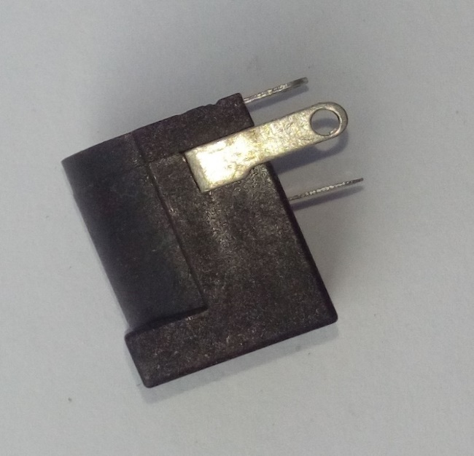

Fig4.16: Dc socket

4.13 Transistor (BC547)

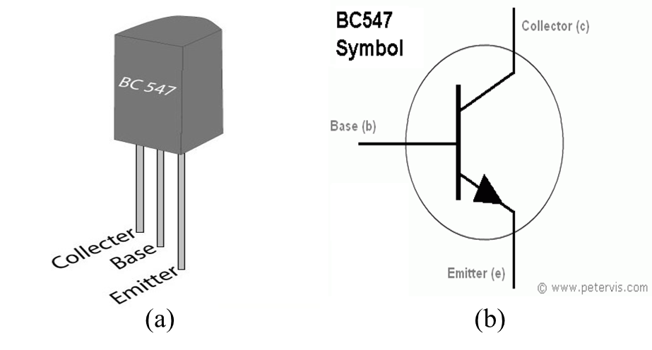

Fig. 4.17: (a) BC547 Transistor and (b) Symbol of BC547 transistor

BC547 is an NPN Bi-polar junction transistor (BJT) as shown in figure 1. A transistor, stands for transfer of resistance, is commonly used to amplify current. A small current at its base controls a larger current at collector & emitter terminals. BC547 is mainly used for amplification and switching purposes. It has a maximum current gain of 800. Its equivalent transistors are BC548 and BC549. The transistor terminals require a fixed DC voltage to operate in the desired region of its characteristic.

4.14 Rectifier Diode

A diode is a two-terminal electronic component that conducts primarily in one direction (asymmetric conductance); it has low (ideally zero) resistance to the current in one direction, and high (ideally infinite) resistance in the other. A semiconductor diode, the most common type today, is a crystalline piece of semiconductor material with a p–n junction connected to two electrical terminals. A vacuum tube diode has two electrodes, a plate (anode) and a heated cathode

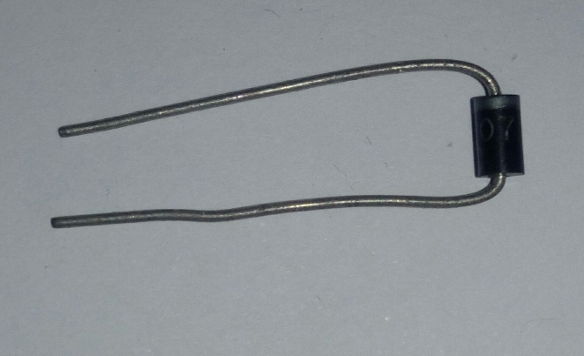

Fig. 4.19: Rectifier diode

#### 

Fig. 4.20: Diode Symbol

4.15 Introduction of GSM Module

The Global System for Mobile Communications is the most popular standard for mobile phones in the world. GSM service is used by over 2 billion people across more than 212 countries and territories. The ubiquity of the GSM standard makes international roaming very common between mobile phone operators, enabling subscribers to use their phones in many parts of the world. GSM differs significantly from its predecessors in that both signaling and speech channels are Digital call quality, which means that it is considered a second generation (2G) mobile phone system. This fact has also meant that data communication was built into the system from the 3rd Generation Partnership Project (3GPP). From the Point of view of the consumers, the key advantage of GSM systems has been higher digital voice quality and low cost alternatives to making cells such as text messaging. The advantage for network operator has been the ability to deploy equipment from different vendors because the open standard allows easy inter-operability. Like other cellular standards GSM allows network operators to offer roaming services which mean subscribers can use their phones all over the world. As the GSM standard continued to develop, it retained backward compatibility with the original GSM phones; for example, packet data capabilities were added in the Release ’97 version of the standard, of GPRS. High meaner speed data transmission has also been introduced with EDGE in the Release ’99 version of the standard.

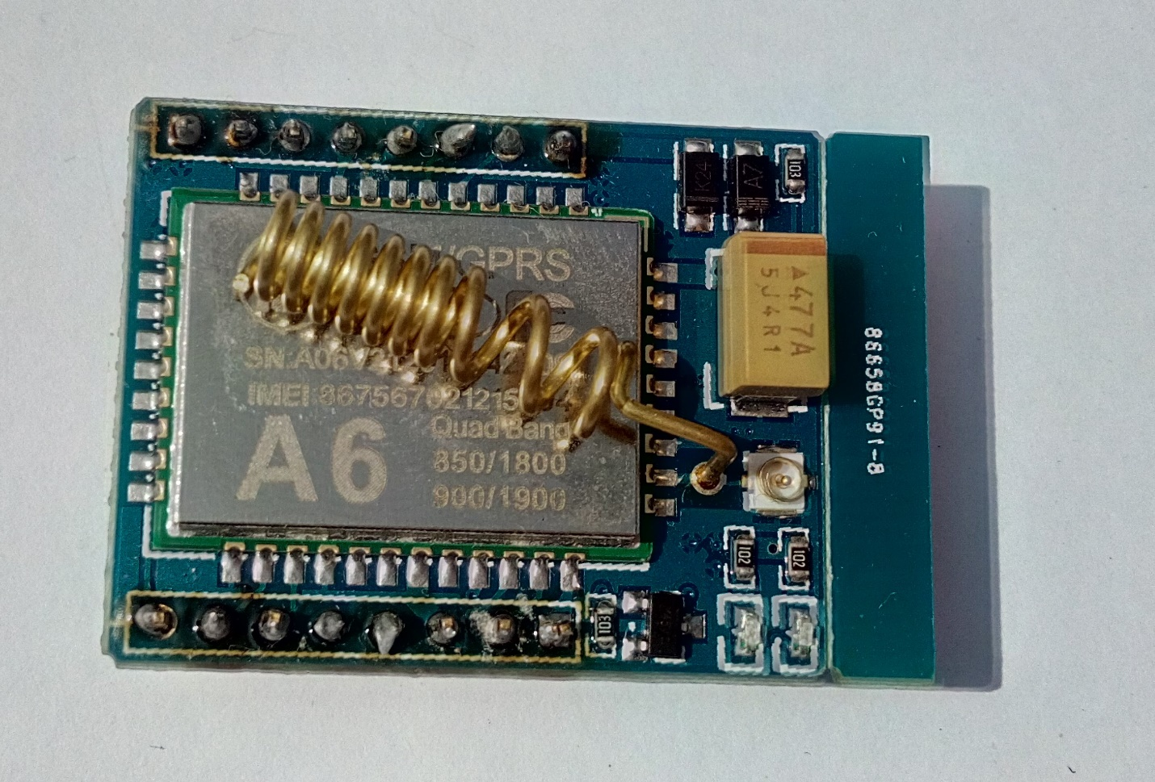

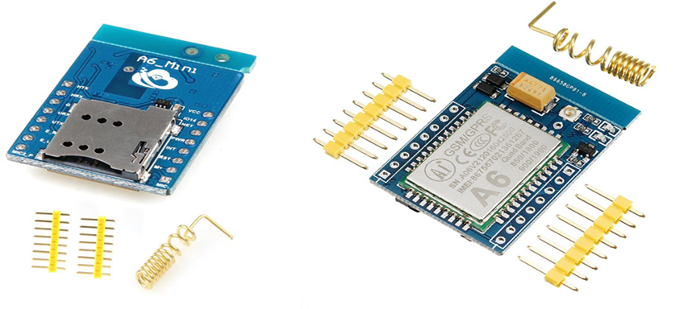

Fig. 4.20: GSM Module

4.15.1 Historical Background of GSM

The growth of cellular telephone system took off in the early 1980s, particularly in Europe. The lack of a technological standardization prompted the European conference of postal and Telecommunications Administrations (CEPT) to create the group Special Mobile (GSM) in 1982 with the objective of developing a standard for a mobile telephone system that could be used across Europe .The first GSM network was launched in 1991 by Radiolinja in Finland.

In 1989, GSM responsibility was transferred to the European Telecommunications Standards Institute (ETSI), and phase I of the GSM specifications were published in 1990.By the end of 1993, over a million subscribers were using GSM phone networks being operated by 70 carriers across 48 countries.

4.15.2 Subscriber Identity Module

One of the key features of GSM is the Subscriber identity Module (SIM), commonly known as a SIM card. The SIM is a detachable smart card containing the user’s subscription information and phone book. This allows the user to retain his or her information after switching handsets. Alternatively, the user can also change operators while retaining the handset simply by changing the SIM. Some operators will block this by allowing the phone to use only a single SIM, or only a SIM issued by them, this practice is known as SIM looking, and is illegal in some countries.

In the United States, Canada, Europe and Australia, many operators lock the mobiles the sell. This is done because the price of the mobile phone is typically subsidized with revenue from subscriptions and operators want to try to avoid subsidizing competitor mobiles .A subscriber can usually contact the provider to remove the look for a fee, utilize private services to remove the look, or make use of ample software and websites available on the Internet to unlock the handset themselves. While most web sites offer the unlocking for a fee, some do it for free. The locking applies to the handset, identified by its international Mobile Equipment Identity (IMEI) number, not to the account. It is always possible to switch to another handset if such other handset is available. Some providers will unlock the phone for free if the custom has held an account for a certain period. Third party unlocking services exist that are often quicker and lower cost than that of the operator, in most removing the lock is legal.

2.15.3 What is GSM

In Europe, Asia or Japan and using a mobile phone, then most probably you must using GSM technology in your mobile phone.

* GSM stands for **G**lobal System for Mobile Communication and is an open, digital cellular technology used for transmitting mobile voice and data services.
* The GSM emerged from the idea of cell-based mobile radio systems at Bell laboratories in the early 1970s.
* The GSM is the name of a standardization group established in 1982 to create a common European mobile telephone standard.
* The GSM standard is the most widely accepted standard and is implemented globally.
* The GSM is a circuit-switched system that divides each 200 kHz channel into eight 25
* KHz time-slots. GSM operates in the 900 MHz and 1.8 GHz bands in Europe and the 1.9GHz and 850 MHz bands in the US.
* The GSM is owning a market share of more than 70 percent of the world's digital cellular subscribers.
* The GSM makes use of narrowband Time Division Multiple Access (TDMA) technique for transmitting signals.
* The GSM was developed using digital technology. It has an ability to carry 64 kbps to 120 Mbps of data rates.
* Presently GSM supports more than one billion mobile subscribers in more than 210countries throughout the world.
* The GSM provides basic to advanced voice and data services including Roaming service. Roaming is the ability to use your GSM phone number in another GSM network. A GSM digitizes and compresses data, then sends it down through a channel with two other streams of user data, each in its own time slot. It operates at either the 900 MHz or 1,800 MHz frequency band.

4.15.4 Why GSM

The GSM study group aimed to provide the followings through the GSM:

• Improved spectrum efficiency.

• International roaming.

• Low-cost mobile sets and base stations (BSs).

• High-quality speech.

• Compatibility with Integrated Services Digital Network (ISDN) and other telephone company Services.

• Support for new services.

3.15.5 GSM Services

GSM services are a standard collection of applications and features available to mobile phone subscribers all over the world. The GSM standards are defined by the 3GPP collaboration and implemented in hardware and software by equipment manufacturers and mobile phone operators. The common standard makes it possible to use the same phones with different companies. Services, or even roam into different countries. GSM is the world most dominant mobile phone standard.

The design of the service is moderately complex because it must be able to locate a moving phone anywhere in the world, and accommodate the relatively short battery life, limited input/output capabilities, and weak radio transmitters on mobile devices.

3.15.6 GSM/GPRS Modem (SIM6A)

GSM/GPRS Modem is built with Dual Band GSM/GPRS engine-SIM6A works on frequencies 900/ 1800 MHz the Modem is coming with RS232 interface, which allows you connect PC as well as microcontroller with RS232 Chip (MAX232).The baud rate is configurable from 9600-115200 through AT command .The GSM/GPRS Modem is having internal TCP/IP stack to enable you connect with internet via GPRS. It is suitable for SMS, Voice as well as DATA transfer application in M2M interface. The onboard Regulated power supply allows you to connect wide range unregulated power supply. Using this modem wean make audio calls, SMS, SMS, attend the incoming calls and internet through simple AT commands.

4.15.7 Application of GSM Module (SIM6A)

• Phone Call based Remote Control and Alerts

• Security Applications

• Sensor Monitoring

• GPRS Mode Remote Data Logging

4.16 What is Solar Energy

Solar power is energy from the sun and without its presence all life on earth would end. Solar energy has been looked upon as a serious source of energy for many years because of the vast amounts of energy that are made freely available, if harnessed by modern technology. A simple example of the power of the sun can be seen by using a magnifying glass to focus the sun’s rays on a piece of paper. Before long the paper ignites into flames.

4.16.1 How does Solar Power Work

Just how does sunshine become electricity? Here's an overview of the solar energy facts, the process, and the equipment that can help you generate your own clean, more affordable energy.

4.16.2 Solar Panels

The solar panels are made up of photovoltaic (PV) cells, which convert sunlight into direct current (DC) electricity throughout the day. Solar panels are devices that convert light into electricity. They are called "solar" panels because most of the time, the most powerful source of light available is the Sun, called Sol by astronomers. Some scientists call them photovoltaic’s which means, basically, "light-electricity." A solar panel is a collection of solar cells. Lots of small solar cells spread over a large area can work together to provide enough power to be useful. The more light that hits a cell, the more electricity it produces, so spacecraft are usually designed with solar panels that can always be pointed at the Sun even as the rest of the body of the spacecraft moves around, much as a tank turret can be aimed independently of where the tank is going.

4.16.3 Advantages in Using Solar Energy

Other energy sources being used are indirectly derived from the sun. The most common energy sources being used today like gas, coal, and petroleum are ancient biological material that derived their energy from the sun.

Sunlight can be used to directly generate electricity by the use of photovoltaic technology. The use of solar cells or photovoltaic arrays is getting more and more acceptable as an alternative and cost efficient means of generating power. Sunlight concentration is also another way of using solar energy. Heat is also more readily usable than the energy in sunshine. You can use it for heating a building or for cooking or even for generating electricity.

**The abundance of Solar Energy:** Even in the middle of winter each square meter of land still receives a fair amount of solar radiation. Sunlight is everywhere and the resource is practically inexhaustible. Even during cloudy days we still receive some sunlight and it is this that can be used as a renewable resource.

**You don’t pay for sunlight:** Sunlight is totally free. There is of course the initial investment for the equipment. After the initial capital outlay you won’t be receiving a bill every month for the rest of your life from the electric utility.

**Solar energy is getting more cost effective:** The technology for solar energy is evolving at an increasing rate. At present photovoltaic technology is still relatively expensive but the technology is improving and production is increasing. The result of this is to drive costs down. Payback times for the equipment are getting shorter and in some areas where the cost of electricity is high payback may be as short as five years.

**Solar energy is non-polluting:** Solar energy is an excellent alternative for fossil fuels like coal and petroleum because solar energy is practically emission free while generating electricity. With solar energy the danger of further damage to the environment is minimized. The generation of electricity through solar power produces no noise. So noise pollution is also reduced.

**Accessibility of solar power in remote locations:** Solar power can generate electricity no matter how remote the area as long as the sun shines there. Even in areas that are inaccessible to power cables solar power can produce electricity.

**Solar energy systems are virtually maintenance free:** Once a photovoltaic array is setup it can last for decades. Once they are installed and setup there are practically zero recurring costs. If needs increase solar panels can be added with ease and with no major revamp.

CHAPTER 5

RESULTs AND DISCUSSIONS

5.1 Introduction

Result presents the success as well as the satisfaction. It inspires us to work and keep it up. In this chapter, we show our experiment result and briefly discuss about that. Here also show the cost analysis of our project in this chapter

5.2 Result of the Project

* With our project we became successful to demonstrate with regarding the objectives of the project.
* The moisture content of the three different types of field was measured successfully.
* Motor automatically turn on or off with the different level of moisture content in the soil.
* Gardener or Farmer successfully got the status of his fields whether dry or wet by LCD.

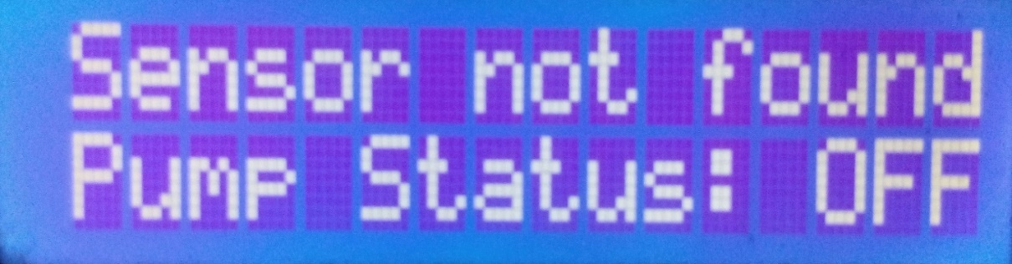

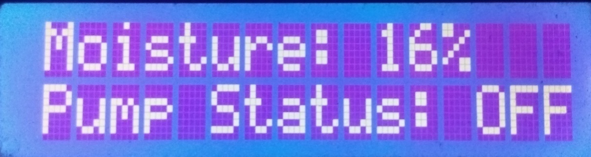

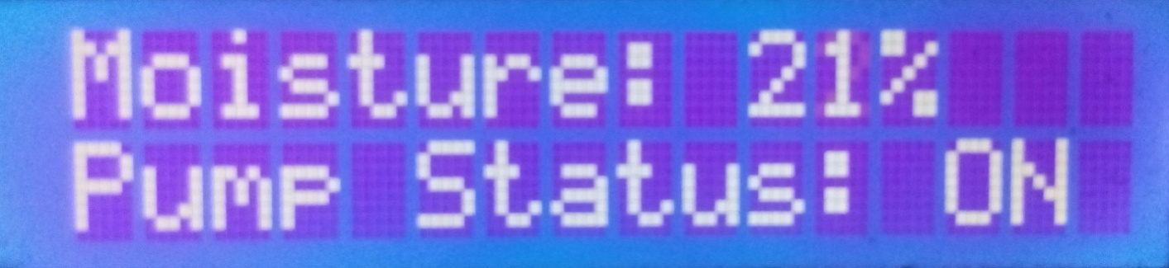

Figure 5.1: Showing the moisture level and pump status on LCD

5. 3 Project Physical View

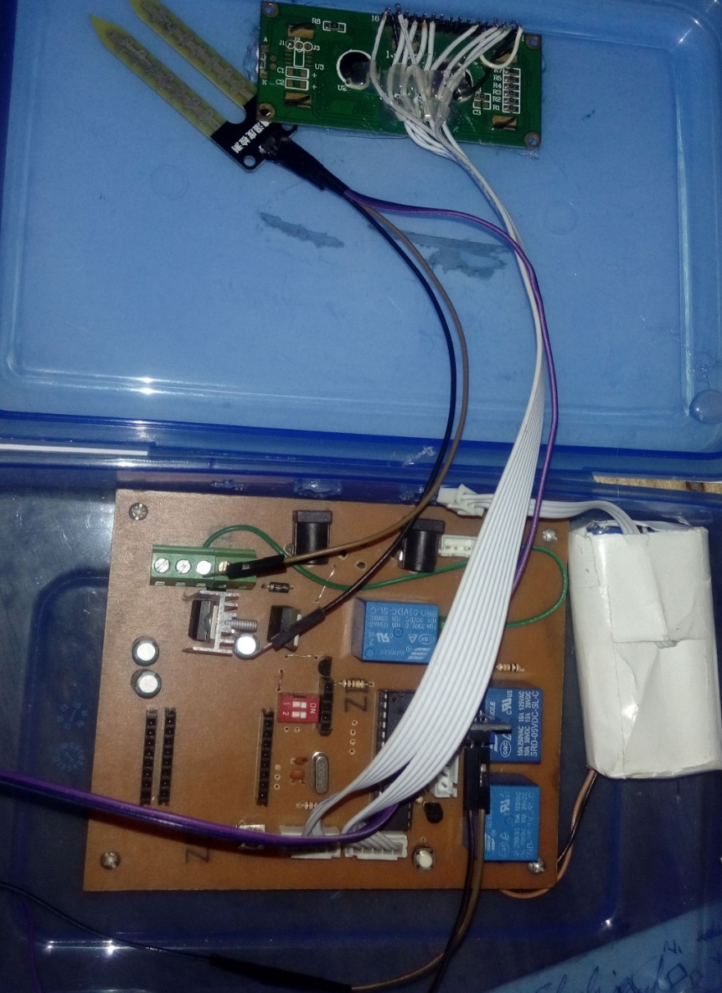

Fig 5.2: Project Physical View

5.3 Total Project Cost, Quantity and Price

Table 5.1: Total Project Cost, Quantity and Price

|  |  |  |  |
| --- | --- | --- | --- |
| **SL** | **Equipment Name** | **Quantity** | **Price (TK)** |
| 1 | ATMega328 | 1 | 170 |
| 2 | Pump | 1 | 300 |
| 3 | Soil Moisture Sensor | 1 | 160 |
| 4 | Solar | 1 | 500 |
| 5 | 16*2 Display | 1 | 160 |
| 6 | Battery (8v) | 1 | 90 |
| 7 | PCB Connector (2 Pin) | 2 | 6 |
| 8 | PCB Connector (3Pin) | 1 | 7 |
| 9 | Transistor | 3 | 6 |
| 10 | Relay (5V) | 1 | 20 |
| 11 | IC Socket (28 Pin) | 1 | 25 |
| 12 | DC Connector (7805) | 2 | 20 |
| 13 | Voltage Regulator | 2 | 20 |
| 14 | Capacitor (22PF) | 2 | 2 |
| 15 | Capacitor (100UF) | 3 | 2 |
| 16 | Plastic Box | 1 | 50 |
| 17 | SIL Heater Socket Row strip pos Connector | 2 | 40 |
| 18 |  |  |  |
| 19 |  |  |  |
| 20 |  |  |  |
| 21 |  |  |  |
| 22 |  |  |  |
| 23 |  |  |  |
|  |  |  |  |

# 

5.4 Advantages of this project

• Anyone can use this

• Gardener and farmer can use this

• Cost efficient

• Saving time, power and water

• Low power consumption

• Easy to Setup

• It can be use in agricultural research also

5.5 Dis-advantages

• This is applicable for only flat area

• Have limited life after installation due to the decoration of the plastic component in a hot, arid climate when exposed to ultraviolet light to ultraviolet light.

5.6Application

• Gardens and Fields can use this

• It can be use in agricultural research Irrigation

• It is effective in Pisciculture

5.7 Discussion

The main objective of this project is to design a low cost device in order to control the water pump automatically. This automatic irrigation system senses the moisture content of the soil and automatically switches the pump when the power is on. A proper usage of irrigation system is very important because the main reason is the shortage of land reserved water due to lack of rain, unplanned use of water as a result large amounts of water goes waste. For this reason, we use this automatic plant watering system, and this system is very useful in all climatic conditions. The project is designed to develop an automatic irrigation system which switches the pump motor ON/OFF on sensing the moisture content of the soil. In the field of agriculture, use of proper method of irrigation is important. The project uses an ARDUINO NANO open source microcontroller which is programmed to receive the input signal of varying moisture condition of the soil through the sensing arrangement. Once the controller receives this signal, it generates an output that drives a relay for operating the water pump. An automation of irrigation systems has several positive effects. Once installed, the water distribution on fields or small-scale gardens is easier and does not have to be permanently controlled by an operator. There are several solutions to design automated irrigation systems.

5.8 Summary of the Results and discussions

In this chapter, we briefly discuss and show the result of our experiment. Here, we show several outputs and try to make it easier. And we also Advantages and added the cost analysis. So, we hope that this project will be helpful for gardener and farmer their garden and plant water in.

CHAPTER 6

CONCLUSIONSIONs

5.1 Conclusions

The primary applications for this project are for gardeners and farmers who do not have enough time to water their crops/plants. It also covers those farmers who are wasteful of water during irrigation. The project can be extended to greenhouses where manual supervision is far and few in between. The principle can be extended to create fully automated gardens and farmlands. Combined with the principle of rain water harvesting, it could lead to huge water savings if applied in the right manner. In agricultural lands with severe shortage of rainfall, this model can be successfully applied to achieve great results with most types of soil.

5.2 Limitations of the work

In the load shading period the machine will be turn off and measuring process will also turn off automatically. By adding the battery backup, we can remove this problem. Accept it, we are getting some noise from our sensor. By adding a better sensor, we can remove this problem. This moisture uptake method relies upon several assumptions and it has been shown that the results can deviate up to 10% from the true value.

5.3 Future scope of the work

This project can be further developed in future by adding GSM module to make a text message or phone call for alarm. Without it, we can enhance the feature of this project by using solar technology for power supply We can also measure water level of my reserve water tank can be monitored using this technology.

–

REFERENCES

### Website:

[1] https://www.arduino.cc/en/Main/ArduinoBoardUnoretrieved

[2] https://www.arduino.cc/en/Guide/Introductionretrieved

[3] <https://en.wikipedia.org/wiki/Relay> History

[4] <http://electronicsforu.com/electronics-projects/automated-plants-watering> system

[5] https://en.wikipedia.org/wiki/Soil moisture sensor

[6] https://en.wikipedia.org/wiki/Resistor

[7] https://en.wikipedia.org/wiki/Capacitor

[8] https://www.sunfounder.com/wiki/index.php?title=2_Channel_5V_Relay_Module

[9] http://www.geeetech.com/wiki/index.php/2-Channel_Relay_module

**YouTube:**

[10] https://www.youtube.com/watch?v=pCxeZkLhqSE

[11] https://www.youtube.com/watch?v=BKp4ib1UQj8

**Journal Papers and others:**

[1] S. V. Devika, Sk. Khamuruddeen, Sk. Khamurunnisa, JayanthThota, KhaleshaShaik Volume_4/10_October2014

[2] Nagarajapandian, Ram Prasanth, Selva Kumar, Tamil Sylvan

Assistant professor,

Dept. of EIE, Sri Ramakrishna Engineering College,

Coimbatore, Tamilnadu, India 1 UG Student,

Dept. of EIE, Sri Ramakrishna Engineering College, Coimbatore,

Tamilnadu, India2, 3,

[3] SHAIKH SHEROZ MOHD HASAN Department of Electronics and Telecommunication Engineering Anjuman-I-Islam Kalsekar Technical Campus, New Panvel MUMBAI UNIVERSITY http://www.aiktcdspace.org:8080/jspui/bitstream/123456789/1572/1/PE0127.pdf <http://gardenbot.org/howTo/soilMoisture>

[4] Knight, J.H., 1992: Sensitivity of time domain reflectometry measurements to lateral variations in soil water content. Water Resources Research, 28, pp. 2345–2352.

[5] Prathyusha.K1, G. Sowmya Bala2, Dr. K. Sreenivasa Ravi, ―A real time irrigation control system for precision agriculture using WSN in Indian agricultural sectors‖ International Journal of Computer Science, Engineering and Applications (IJCSEA) Vol.3, No.4, August 20.